PROJECT REPORT

ON

LIBRARY MANAGEMENT SYSTEM

FOR THE PARTIAL FULFILLMENT OF
BCA

UNDER THE GUIDENCE OF
DIVAYNSHU SINGHNA

SUBMITTED BY

NAME :
ROLL:
SESSION :

INDEX

- Acknowledgement
- Introduction of project
- Process model used
- Software Requirement Specification
- Services provided to the user
- Entity Relationship Diagram
- Data Flow Diagram
- Coding class and structure definitions
- Output
- Testing

ACKNOWLEDGEMENT

We express our sincere thanks to all those who have provided us valuable guidance towards the completion of this system as part of the syllabus of the computer science and Engineering course.
We express our sincere gratitude towards our co-operative department which has provided us with valuable assistance for the system development.

INTRODUCTION

Objective of project: To provide a Library Management System for college
Library, which would provide all library functions?

Rational: To improve library uses services and reduce paperwork.

Scope of Project:

- To make the existing system more efficient.
- To provide a user friendly environment where user can be serviced better.
- Make functioning of library faster.
- Provide a system where the library staff can catch defaulters and not let them escape.
- To minimize the loss done to book

Process model used

In my project, I have used waterfall model. This model is used when requirements are well defined and reasonably stable, and in my project ‘Library Management System’ all the requirements are well defined.

The waterfall model, sometimes called the classic life cycle, suggests a systematic, sequential approach to software development that begins with customer specification of requirements and progresses through planning, modeling, construction and deployment, culminating in on-going support of the complete software.

I have defined activities and represented them into separated process phases. All the stages overlap and fed information to each other. It is not a simple linear model but involves a sequence of iterations of development activities.

This model is appropriate for my project as I had ample of time for designing it, so the time constraints were not there. This model generally takes more time to complete the software life cycle as when a stage completes it is signed off and development goes onto the next stage.

Requirements Specification

Functional requirements:

- Accession number, roll number and teacher identification must all be unique as they form the primary keys of the respective tables.
- All new books must be entered in the accession table first, to avoid problems later.
- A book must not be deleted from student profile unless and untill she pays the appropriate fine or the same book.
- While inserting values in the database, only valid values must be entered.

Data requirements:

- The Library Management System shall be required to maintain information about its users and books.
- It shall store databases for students, teachers and books.
- The student database stores information about a student’s roll no, name, address, course and year.
- The book database stores information about a book title, author, publisher, cost, bill number, year of publishing and pages.
- The teacher database stores information about a teacher’s id, name, department, designation, address and telephone number.

Software requirements:
The system on which the Library Management System is installed must have Microsoft windows in it.

Hardware requirements:
Genuine Intel, x86 Family 15 Model 2 Stepping 4, 120.0 MB RAM.
Services provided to the user

The Library Management System automates the basic library functions to aid in the day-to-day operations of a library. It supports functions such as issue, return, the very basic functions of searching for a particular book, etc.
It also maintains data about books about books, teachers, students records that are required during various library operations. The software aims to make the system user friendly and efficient.

The functions that the Library Management System provides are as follows:

- INSERT: This operation is performed when new data needs to be added to the system, for e.g. when department purchases a new book, the book’s entry is inserted in the books database. This option has three choices:
- Book: This choose allows entering data about newly purchased books into the books database. The data entered includes book’s author, title, publisher, cost and various other fields provided in the form. The data must be accurate and must be entered in the correct format as indicated in the forms.
- Teacher: This option is used for entering data for a new teacher in the teacher’s database. This option is chosen when a teacher joins college.
- Student: This will enter new record for a student in student’s database. This option is chosen when a student is enrolled in the college.
- DELETE: This operation clears the existing records in the various databases. It is used when for e.g. a member leaves college or when book is disposed of from library. But care must be taken while performing this operation and permission taken from the head of library because the system could loose any important data.
It can be performed on all databases and on three choices are:
  - Book: This will enter a null value for the book whose accession number is entered in the field provided in the respected form. This operation is done when a book is disposed of the library.
  - Teacher: This will clear the record for a particular teacher whose identification number is entered. This option is chosen when a teacher leaves college.
  - Student: This will clear the record for the particular student whose record needs to be deleted by entering her roll number in the required field. This option is chosen when a student leaves college.

- UPDATE: This function updates data in the various records. This operation is supported by all the three entries:
  - Book: This function generally would not be required for updating a book’s status as that data wouldn’t change.
  - Teacher: This will update the data of particular teacher, whose data has changed like address, phone number, etc. by entering her identification number.
  - Student: This will update the data of student like address, course, etc. by entering student’s roll number.

- SEARCH: This function is used to search particular data from the database. This function can search for data related to all the
Three entities:
  - Book: To search for a particular book, to know whether it is currently available in library or not. This can be done by entering value in any one or more fields in the form to perform the search such as title or author name.
  - Teacher: This will find out the particular teacher who currently has the book for which search is being carried out.
  - Student: This will find out the particular student who possesses the particular book.

- ISSUE: This operation is used for issuing a book to a member of the library. For this operation to be successful the member must meet
Some criteria like she should not have issued books to her maximum
Limit previously. All these checks are done by software. If the
Operation is successful, then the system automatically stores the
Date of issue and the due date by which the book must be returned.
- Student: When a student loans a book, the entry of the book is stored automatically in the student’s database with the due date of that book.
- Teacher: In case a member of teaching staff loans a book the entry is stored in teacher’s database with the due date of the book.
- RETURN: Using this operation a member returns the items, which she loaned, from the library back to it. If the book, which is loaned is not returned within specified time the member ends up as a defaulter and she is required to pay fine which is calculated automatically by the software.
  - Teacher: It will delete the corresponding entry made in teacher’s database.
  - Student: It will delete the corresponding entry made in student’s database.
- DISPLAY: This is used to display each and every record, i.e. record of every book, teacher and student in the library.
- Book: Record of every book, i.e. it’s accession number, author name, publisher name, etc.
- Teacher: Record of every teacher, i.e. her id, department, no. of books issued, etc., who is member of the college library.
- Student: Record of every student, i.e. her roll number, course, no of books issued, etc., who is member of the college library.
- EXIT: This takes user out of the application.

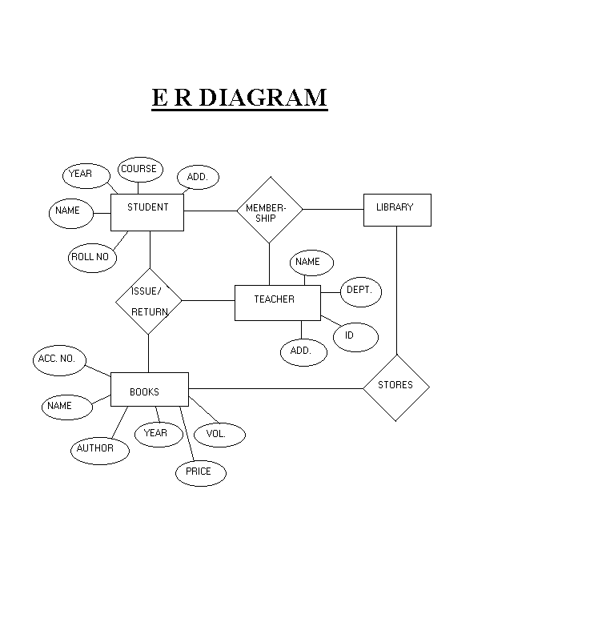

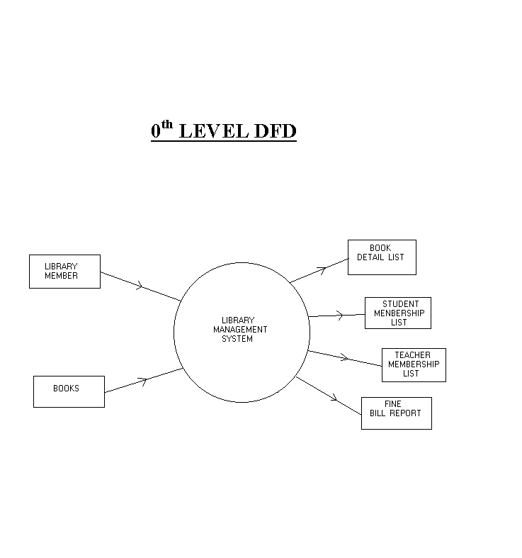

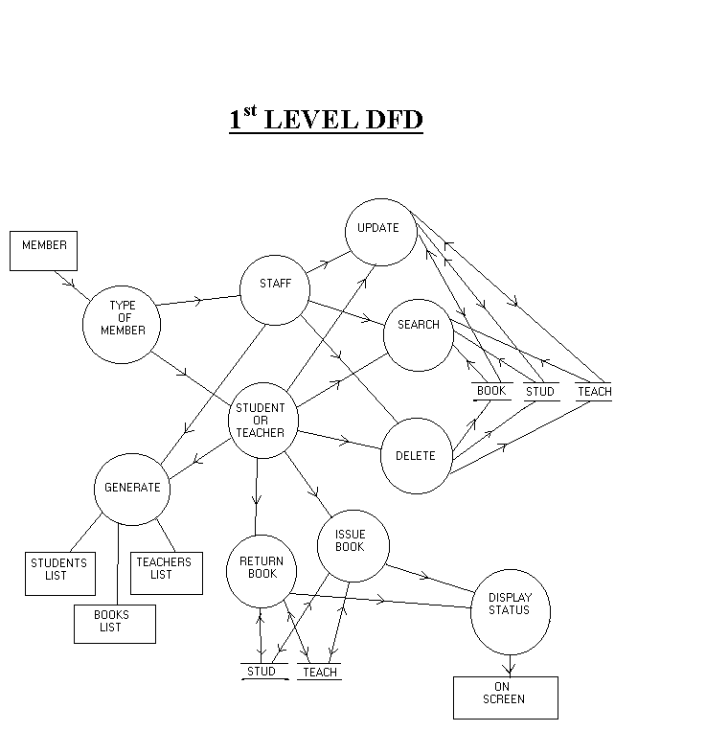
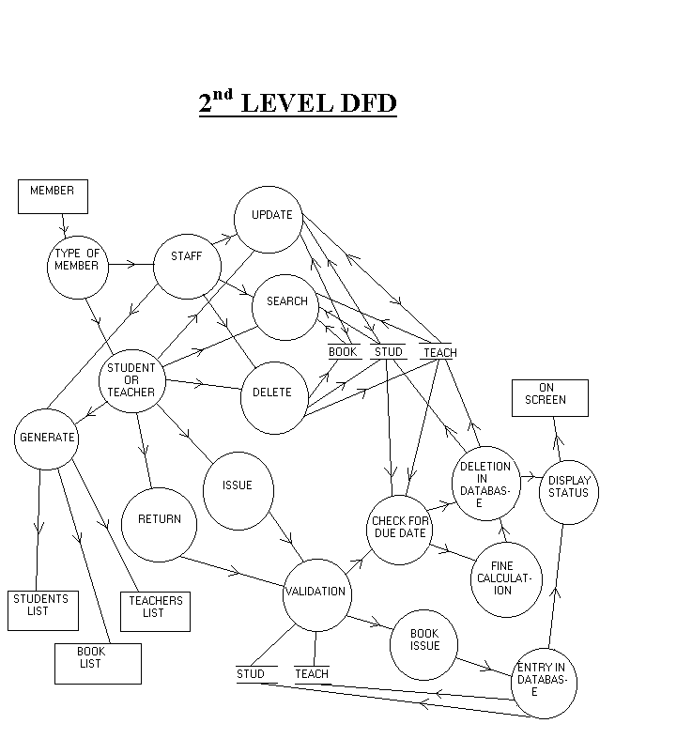

#include <iostream.h>
#include <fstream.h>
#include <process.h>
#include <string.h>
#include <stdlib.h>
#include <stdio.h>
#include <ctype.h>
#include <conio.h>
#include <dos.h>

//**********************************************************
// THIS CLASS CONTROL ALL THE FUNCTIONS IN THE MENU
//**********************************************************

class MENU
{
public :
void main_menu(void) ;
void introduction(void) ;
private :
void edit_menu(void) ;
void edit_book(void) ;
void edit_member(void) ;
} ;

//**********************************************************
// THIS CLASS CONTAINS FUNCTIONS RELATED TO BOOKS
//**********************************************************

class BOOK
{
public :
void list(void) ;
char *bookname(int) ;
protected :
void add_new_book(int, char tname[33], char tauthor[26], float, int, int) ;
void update_copies(int, int, int) ;
void modify(int, char[], char[], float) ;
void deletion(void) ;
int book_found(int) ;
int bookname_found(char []) ;
int recordno(int) ;
int available(int) ;
char *authorname(int) ;
float bookprice(int) ;
int no_of_copies(int) ;
int bookcodeof(char[]) ;
void display(int) ;
int reccount(void) ;
void delete_rec(int) ;
private :
int bookcode, copies ;
char name[33], author[26] ;
float price ;
int avail ;
} ;

//**********************************************************
// THIS CLASS CONTAINS FUNCTIONS RELATED TO MEMBERS
//**********************************************************

class MEMBER
{
public :
void list(void) ;
protected :
void add_mem(int, int, char [], char [], char[], int, int, int) ;
void modify(int, char[], char[], char[]) ;
int member_found(int) ;
void update_book(int, int, int, int, int) ;
char *membername(int) ;
char *memberphone(int) ;
char *memberaddress(int) ;
int recordno(int) ;
int lastcode(void) ;
int issued(int) ;
int fine(int) ;
void display(int) ;
void delete_rec(int) ;
private :
int memcode, bookcode ;
char name[26], phone[10], address[33] ;
int dd, mm, yy ; // DATE OF RETURNING THE BOOK //
} ;

//**********************************************************
// THIS IS DERIVED FROM CLASS BOOK & MEMBER AND CONTAINS
// FUNCTIONS FOR WORKING (ISSUE,RETURN,ETC).
//**********************************************************

class WORKING : public BOOK, public MEMBER
{
public :
void issuebook(void) ;
void returnbook(void) ;
void add_book(void) ;
void add_member(void) ;
void modify_book(void) ;
void modify_member(void) ;
void delete_book(void) ;
void delete_member(void) ;
} ;

//**********************************************************
// THIS CLASS CONTAINS FUNCTIONS RELATED DATE & FINE
//**********************************************************

class DATE
{
public :
void extend_date(int,int,int,int) ;
int diff(int, int, int, int, int, int) ;
int day, mon, year ;
} ;

//**********************************************************
// FUNCTION TO EXTEND GIVEN DATE BY 15 DAYS
//**********************************************************

void DATE :: extend_date(int d1, int m1, int y1, int days)
{
static int month[] = {31,29,31,30,31,30,31,31,30,31,30,31} ;
for (int i=1; i<=days; i++)
{
d1++ ;
if ((d1 > month[m1-1]) || (y1%4 != 0 && m1 == 2 && d1 > 28))
{
d1 = 1 ;
m1++ ;
}
if (m1 > 12)
{
m1 = 1 ;
y1++ ;
}
}
day = d1 ;
mon = m1 ;
year = y1 ;
}

//**********************************************************
// THIS FUNCTION RETURN THE DIFFERENCE BETWEEN TWO GIVEN
// DATES
//**********************************************************

int DATE :: diff(int d1, int m1, int y1, int d2, int m2, int y2)
{
int days = 0 ;
if ((y2<y1) || (y2==y1 && m2<m1) || (y2==y1 && m2==m1 && d2<d1))
return days ;
static int month[] = {31,29,31,30,31,30,31,31,30,31,30,31} ;
while (d1 != d2 || m1 != m2 || y1 != y2)
{
days++ ;
d1++ ;
if ((d1 > month[m1-1]) || (y1%4 != 0 && m1 == 2 && d1 > 28))
{
d1 = 1 ;
m1++ ;
}
if (m1 > 12)
{
m1 = 1 ;
y1++ ;
}
}
return days ;
}

//**********************************************************
// FUNCTION TO DISPLAY MAIN MENU & CONTROL ALL THE FUNCTION
// IN THE MAIN MENU.
//**********************************************************

void MENU :: main_menu(void)
{
char ch ;
while (1)
{
clrscr() ;
gotoxy(29,6) ;
cout <<"B O O K L I B R A R Y" ;
gotoxy(29,7) ;
cout <<"~~~~~~~~~~~~~~~~~~~~~~" ;
gotoxy(30,10) ;
cout <<"1. INTRODUCTION" ;
gotoxy(30,11) ;
cout <<"2. ADD NEW BOOK" ;
gotoxy(30,12) ;
cout <<"3. ADD NEW MEMBER" ;
gotoxy(30,13) ;
cout <<"4. ISSUE BOOK" ;
gotoxy(30,14) ;
cout <<"5. RETURN BOOK" ;
gotoxy(30,15) ;
cout <<"6. LIST OF BOOKS" ;
gotoxy(30,16) ;
cout <<"7. LIST OF MEMBERS" ;
gotoxy(30,17) ;
cout <<"8. EDIT" ;
gotoxy(30,18) ;
cout <<"0. QUIT" ;
gotoxy(30,20) ;
cout <<"Enter your choice : " ;
ch = getche() ;
if (ch == 27)
break ;
else
if (ch == '1')
introduction() ;
else
if (ch == '2')
{
WORKING W ;
W.add_book() ;
}
else
if (ch == '3')
{
WORKING W ;
W.add_member() ;
}
else
if (ch == '4')
{
WORKING W ;
W.issuebook() ;
}
else
if (ch == '5')
{
WORKING W ;
W.returnbook() ;
}
else
if (ch == '6')
{
BOOK B ;
B.list() ;
}
else
if (ch == '7')
{
MEMBER M ;
M.list() ;
}
else
if (ch == '8')
edit_menu() ;
else
if (ch == '0')
break ;
}
}

//**********************************************************
// FUNCTION TO DISPLAY EDIT MENU
//**********************************************************

void MENU :: edit_menu(void)
{
char ch ;
while (1)
{
clrscr() ;
gotoxy(32,9) ;
cout <<"E D I T M E N U";
gotoxy(32,10) ;
cout <<"~~~~~~~~~~~~~~~~" ;
gotoxy(34,13) ;
cout <<"1. BOOKS" ;
gotoxy(34,14) ;
cout <<"2. MEMBERS" ;
gotoxy(34,15) ;
cout <<"0. EXIT" ;
gotoxy(31,17) ;
cout <<"Enter your choice : " ;
ch = getche() ;
if (ch == 27)
break ;
else
if (ch =='1')
edit_book() ;
else
if (ch == '2')
edit_member() ;
else
if (ch == '0')
break ;
}
}

//**********************************************************
// FUNCTION TO DISPLAY EDIT MENU FOR BOOK & CONTROL
// ALL THE FUNCTION IN THE EDIT MENU.
//**********************************************************

void MENU :: edit_book(void)
{
char ch ;
while (1)
{
clrscr() ;
gotoxy(31,9) ;
cout <<"E D I T B O O K S";
gotoxy(31,10) ;
cout <<"~~~~~~~~~~~~~~~~~~" ;
gotoxy(34,13) ;
cout <<"1. MODIFY" ;
gotoxy(34,14) ;
cout <<"2. DELETE" ;
gotoxy(34,15) ;
cout <<"0. EXIT" ;
gotoxy(31,17) ;
cout <<"Enter your choice : " ;
ch = getche() ;
if (ch == 27)
break ;
else
if (ch == '1')
{
WORKING W ;
W.modify_book() ;
}
else
if (ch == '2')
{
WORKING W ;
W.delete_book() ;
}
else
if (ch == '0')
break ;
}
}

//**********************************************************
// FUNCTION TO DISPLAY EDIT MENU FOR MEMBERS & CONTROL
// ALL THE FUNCTION IN THE EDIT MENU.
//**********************************************************

void MENU :: edit_member(void)
{
char ch ;
while (1)
{
clrscr() ;
gotoxy(29,9) ;
cout <<"E D I T M E M B E R S";
gotoxy(29,10) ;
cout <<"~~~~~~~~~~~~~~~~~~~~~~" ;
gotoxy(34,13) ;
cout <<"1. MODIFY" ;
gotoxy(34,14) ;
cout <<"2. DELETE" ;
gotoxy(34,15) ;
cout <<"0. EXIT" ;
gotoxy(29,17) ;
cout <<"Enter your choice : " ;
ch = getche() ;
if (ch == 27)
break ;
else
if (ch == '1')
{
WORKING W ;
W.modify_member() ;
}
else
if (ch == '2')
{
WORKING W ;
W.delete_member() ;
}
else
if (ch == '0')
break ;
}
}

//**********************************************************
// FUNCTION TO DISPLAY THE INTRODUCTION FOR THE PROJECT.
//**********************************************************

void MENU :: introduction(void)
{
clrscr() ;
gotoxy(31,5) ;
cout <<"Welcome to Project" ;
textcolor(BLACK+BLINK) ; textbackground(WHITE) ;
gotoxy(33,7) ;
cprintf(" BOOK LIBRARY ") ;
textcolor(LIGHTGRAY) ; textbackground(BLACK) ;
gotoxy(15,10) ;
cout <<"This project has facility of maintaining records" ;
gotoxy(15,11) ;
cout <<"of BOOKS and MEMBERS." ;
gotoxy(15,13) ;
cout <<"This project can hold more than 10,000 books" ;
gotoxy(15,14) ;
cout <<"records." ;
gotoxy(15,16) ;
cout <<"One member can issue one book at a time. If he/she" ;
gotoxy(15,17) ;
cout <<"does not return book upto 15 days he/she have to" ;
gotoxy(15,18) ;
cout <<"pay fine of Rs.2/- per day." ;
textcolor(LIGHTGRAY+BLINK) ;
gotoxy(27,24) ;
cprintf("Press any key to continue") ;
textcolor(LIGHTGRAY) ;
getch() ;
}

//**********************************************************
// THIS FUNCTION RETURN 0 IF GIVEN BOOK CODE NOT FOUND
//**********************************************************

int BOOK :: book_found(int tcode)
{
fstream file ;
file.open("BOOK.DAT", ios::in) ;
file.seekg(0,ios::beg) ;
int found=0 ;
while (file.read((char *) this, sizeof(BOOK)))
{
if (bookcode == tcode)
{
found = 1 ;
break ;
}
}
file.close() ;
return found ;
}

//**********************************************************
// THIS FUNCTION RETURN 0 IF GIVEN BOOK NAME NOT FOUND
//**********************************************************

int BOOK :: bookname_found(char t1code[33])
{
fstream file ;
file.open("BOOK.DAT", ios::in) ;
file.seekg(0,ios::beg) ;
int found=0 ;
while (file.read((char *) this, sizeof(BOOK)))
{
if (!strcmpi(name,t1code))
{
found = 1 ;
break ;
}
}
file.close() ;
return found ;
}

//**********************************************************
// THIS FUNCTION RETURN RECORD NO. FOR THE BOOK CODE
//**********************************************************

int BOOK :: recordno(int tcode)
{
fstream file ;
file.open("BOOK.DAT", ios::in) ;
file.seekg(0,ios::beg) ;
int count=0 ;
while (file.read((char *) this, sizeof(BOOK)))
{
count++ ;
if (bookcode == tcode)
break ;
}
file.close() ;
return count ;
}

//**********************************************************
// THIS FUNCTION RETURNS THE AVAILABLE COPIES FOR THE GIVEN
// BOOK CODE.
//**********************************************************

int BOOK :: available(int tcode)
{
fstream file ;
file.open("BOOK.DAT", ios::in) ;
file.seekg(0,ios::beg) ;
int tavail=0 ;
while (file.read((char *) this, sizeof(BOOK)))
{
if (bookcode == tcode)
{
tavail = avail ;
break ;
}
}
file.close() ;
return tavail ;
}

//**********************************************************
// THIS FUNCTION RETURNS THE NO. OF COPIES FOR THE GIVEN
// BOOK CODE.
//**********************************************************

int BOOK :: no_of_copies(int tcode)
{
fstream file ;
file.open("BOOK.DAT", ios::in) ;
file.seekg(0,ios::beg) ;
int tcopies=0 ;
while (file.read((char *) this, sizeof(BOOK)))
{
if (bookcode == tcode)
{
tcopies = copies ;
break ;
}
}
file.close() ;
return tcopies ;
}

//**********************************************************
// THIS FUNCTION RETURNS THE BOOK NAME OF THE GIVEN BOOK
// CODE.
//**********************************************************

char *BOOK :: bookname(int tcode)
{
fstream file ;
file.open("BOOK.DAT", ios::in) ;
file.seekg(0,ios::beg) ;
char tname[33] ;
while (file.read((char *) this, sizeof(BOOK)))
{
if (bookcode == tcode)
{
strcpy(tname,name) ;
break ;
}
}
file.close() ;
return tname ;
}

//**********************************************************
// THIS FUNCTION RETURNS THE AUTHOR NAME OF THE GIVEN BOOK
// CODE.
//**********************************************************

char *BOOK :: authorname(int tcode)
{
fstream file ;
file.open("BOOK.DAT", ios::in) ;
file.seekg(0,ios::beg) ;
char tauthor[26] ;
while (file.read((char *) this, sizeof(BOOK)))
{
if (bookcode == tcode)
{
strcpy(tauthor,author) ;
break ;
}
}
file.close() ;
return tauthor ;
}

//**********************************************************
// THIS FUNCTION RETURNS THE BOOK PRICE OF THE GIVEN BOOK
// CODE.
//**********************************************************

float BOOK :: bookprice(int tcode)
{
fstream file ;
file.open("BOOK.DAT", ios::in) ;
file.seekg(0,ios::beg) ;
float tprice=0.0 ;
while (file.read((char *) this, sizeof(BOOK)))
{
if (bookcode == tcode)
{
tprice = price ;
break ;
}
}
file.close() ;
return tprice ;
}

//**********************************************************
// THIS FUNCTION RETURNS THE BOOK CODE OF THE GIVEN BOOK
// NAME.
//**********************************************************

int BOOK :: bookcodeof(char t1code[33])
{
fstream file ;
file.open("BOOK.DAT", ios::in) ;
file.seekg(0,ios::beg) ;
int tcode=0 ;
while (file.read((char *) this, sizeof(BOOK)))
{
if (!strcmpi(name,t1code))
{
tcode = bookcode ;
break ;
}
}
file.close() ;
return tcode ;
}

//**********************************************************
// THIS FUNCTION RETURNS THE NO. OF THE RECORDS IN THE BOOK
// FILE.
//**********************************************************

int BOOK :: reccount(void)
{
fstream file ;
file.open("BOOK.DAT", ios::in) ;
file.seekg(0,ios::beg) ;
int count=0 ;
while (file.read((char *) this, sizeof(BOOK)))
count++ ;
file.close() ;
return count ;
}

//**********************************************************
// THIS FUNCTION DELETES THE RECORD OF THE GIVEN BOOK CODE.
//**********************************************************

void BOOK :: delete_rec(int tcode)
{
fstream file ;
file.open("BOOK.DAT", ios::in) ;
fstream temp ;
temp.open("temp.dat", ios::out) ;
file.seekg(0,ios::beg) ;
while ( !file.eof() )
{
file.read((char *) this, sizeof(BOOK)) ;
if ( file.eof() )
break ;
if ( bookcode != tcode )
temp.write((char *) this, sizeof(BOOK)) ;
}
file.close() ;
temp.close() ;
file.open("BOOK.DAT", ios::out) ;
temp.open("temp.dat", ios::in) ;
temp.seekg(0,ios::beg) ;
while ( !temp.eof() )
{
temp.read((char *) this, sizeof(BOOK)) ;
if ( temp.eof() )
break ;
file.write((char *) this, sizeof(BOOK)) ;
}
file.close() ;
temp.close() ;
}

//**********************************************************
// THIS FUNCTION ADD THE RECORD IN THE BOOK FILE
//**********************************************************

void BOOK :: add_new_book(int tcode,char tname[33], char tauthor[26], float tprice, int tcopies, int tavail)
{
fstream file ;
file.open("BOOK.DAT", ios::app) ;
bookcode = tcode ;
strcpy(name,tname) ;
strcpy(author,tauthor) ;
price = tprice ;
copies = tcopies ;
avail = tavail ;
file.write((char *) this, sizeof(BOOK)) ;
file.close() ;
}

//**********************************************************
// THIS FUNCTION UPDATE THE RECORD IN THE BOOK FILE FOR THE
// GIVEN BOOK CODE
//**********************************************************

void BOOK :: update_copies(int tcode, int tcopies, int tavail)
{
fstream file ;
file.open("BOOK.DAT", ios::in) ;
fstream temp ;
temp.open("temp.dat", ios::out) ;
file.seekg(0,ios::beg) ;
while ( !file.eof() )
{
file.read((char *) this, sizeof(BOOK)) ;
if ( file.eof() )
break ;
if ( bookcode == tcode )
{
copies = tcopies ;
avail = tavail ;
temp.write((char *) this, sizeof(BOOK)) ;
}
else
temp.write((char *) this, sizeof(BOOK)) ;
}
file.close() ;
temp.close() ;
file.open("BOOK.DAT", ios::out) ;
temp.open("temp.dat", ios::in) ;
temp.seekg(0,ios::beg) ;
while ( !temp.eof() )
{
temp.read((char *) this, sizeof(BOOK)) ;
if ( temp.eof() )
break ;
file.write((char *) this, sizeof(BOOK)) ;
}
file.close() ;
temp.close() ;
}

//**********************************************************
// THIS FUNCTION MODIFY THE RECORD IN THE BOOK FILE FOR THE
// GIVEN BOOK CODE
//**********************************************************

void BOOK :: modify(int tcode, char tname[33], char tauthor[26], float tprice)
{
fstream file ;
file.open("BOOK.DAT", ios::in) ;
fstream temp ;
temp.open("temp.dat", ios::out) ;
file.seekg(0,ios::beg) ;
while ( !file.eof() )
{
file.read((char *) this, sizeof(BOOK)) ;
if ( file.eof() )
break ;
if ( bookcode == tcode )
{
strcpy(name,tname) ;
strcpy(author,tauthor) ;
price = tprice ;
temp.write((char *) this, sizeof(BOOK)) ;
}
else
temp.write((char *) this, sizeof(BOOK)) ;
}
file.close() ;
temp.close() ;
file.open("BOOK.DAT", ios::out) ;
temp.open("temp.dat", ios::in) ;
temp.seekg(0,ios::beg) ;
while ( !temp.eof() )
{
temp.read((char *) this, sizeof(BOOK)) ;
if ( temp.eof() )
break ;
file.write((char *) this, sizeof(BOOK)) ;
}
file.close() ;
temp.close() ;
}

//**********************************************************
// THIS FUNCTION DISPLAY THE RECORD FROM THE BOOK FILE
// FOR THE GIVEN BOOK CODE
//**********************************************************

void BOOK :: display(int tcode)
{
fstream file ;
file.open("BOOK.DAT", ios::in) ;
file.seekg(0,ios::beg) ;
while (file.read((char *) this, sizeof(BOOK)))
{
if (bookcode == tcode)
{
gotoxy(5,5) ;
cout <<"Book Code : " <<bookcode ;
gotoxy(5,7) ;
cout <<"Book Name : " <<name ;
gotoxy(5,8) ;
cout <<"Author Name : " <<author ;
gotoxy(5,9) ;
cout <<"Price : Rs." <<price ;
gotoxy(5,10) ;
cout <<"Copies : " <<price ;
gotoxy(5,11) ;
cout <<"Available : " <<avail ;
break ;
}
}
file.close() ;
}

//**********************************************************
// THIS FUNCTION DISPLAY THE LIST OF BOOKS.
//**********************************************************

void BOOK :: list(void)
{
clrscr() ;
int row = 6 , found=0, flag=0 ;
char ch ;
gotoxy(33,2) ;
cout <<"LIST OF BOOKS" ;
gotoxy(32,3) ;
cout <<"~~~~~~~~~~~~~~~" ;
gotoxy(1,4) ;
cout <<"CODE BOOK NAME AUTHOR PRICE COPIES" ;
gotoxy(1,5) ;
cout <<"~~~~~~~~~~~~~~~~~~~~~~~~~~~~~~~~~~~~~~~~~~~~~~~~~~~~~~~~~~~~~~~~~~~~~~~~~~~~~~" ;
fstream file ;
file.open("BOOK.DAT", ios::in) ;
file.seekg(0,ios::beg) ;
while (file.read((char *) this, sizeof(BOOK)))
{
flag = 0 ;
delay(20) ;
found = 1 ;
gotoxy(2,row) ;
cout <<bookcode ;
gotoxy(7,row) ;
cout <<name ;
gotoxy(40,row) ;
cout <<author ;
gotoxy(66,row) ;
cout <<price ;
gotoxy(73,row) ;
cout <<copies ;
textbackground(WHITE) ; textcolor(BLACK) ;
gotoxy(40,row+1) ;
cprintf("STATUS: ") ;
textcolor(BLACK+BLINK) ;
cprintf("%d copies available",avail) ;
textbackground(BLACK) ; textcolor(LIGHTGRAY) ;
if ( row == 22 )
{
flag = 1 ;
row = 6 ;
gotoxy(1,25) ;
cout <<"Press any key to continue or Press <ESC> to exit" ;
ch = getch() ;
if (ch == 27)
break ;
clrscr() ;
gotoxy(33,2) ;
cout <<"LIST OF BOOKS" ;
gotoxy(32,3) ;
cout <<"~~~~~~~~~~~~~~~" ;
gotoxy(1,4) ;
cout <<"CODE BOOK NAME AUTHOR PRICE COPIES" ;
gotoxy(1,5) ;
cout <<"~~~~~~~~~~~~~~~~~~~~~~~~~~~~~~~~~~~~~~~~~~~~~~~~~~~~~~~~~~~~~~~~~~~~~~~~~~" ;
}
else
row = row + 2 ;
}
if (!found)
{
gotoxy(5,10) ;
cout <<"\7Records not found" ;
}
if (!flag)
{
gotoxy(1,25) ;
cout <<"Press any key to continue..." ;
getche() ;
}
file.close () ;
}

//**********************************************************
// THIS FUNCTION RETURN 0 IF THE GIVEN MEMBER CODE NOT FOUND
//**********************************************************

int MEMBER :: member_found(int mcode)
{
fstream file ;
file.open("MEMBER.DAT", ios::in) ;
file.seekg(0,ios::beg) ;
int found=0 ;
while (file.read((char *) this, sizeof(MEMBER)))
{
if (memcode == mcode)
{
found = 1 ;
break ;
}
}
file.close() ;
return found ;
}

//**********************************************************
// THIS FUNCTION RETURN 0 IF THE MEMBER HAVE NOT ISSUED ANY
// BOOK.
//**********************************************************

int MEMBER :: issued(int mcode)
{
fstream file ;
file.open("MEMBER.DAT", ios::in) ;
file.seekg(0,ios::beg) ;
int missue=0 ;
while (file.read((char *) this, sizeof(MEMBER)))
{
if (memcode == mcode)
{
missue = bookcode ;
break ;
}
}
file.close() ;
return missue ;
}

//**********************************************************
// THIS FUNCTION CALCULATE AND RETURN FINE FOR THE GIVEN
// MEMBER CODE.
//**********************************************************

int MEMBER :: fine(int mcode)
{
DATE D ;
int d1, m1, y1 ;
struct date d;
getdate(&d);
d1 = d.da_day ;
m1 = d.da_mon ;
y1 = d.da_year ;
fstream file ;
file.open("MEMBER.DAT", ios::in) ;
file.seekg(0,ios::beg) ;
int days, t_fine ;
while (file.read((char *) this, sizeof(MEMBER)))
{
if (memcode == mcode)
{
days = D.diff(dd,mm,yy,d1,m1,y1) ;
t_fine = days * 2 ;
break ;
}
}
file.close() ;
return t_fine ;
}

//**********************************************************
// THIS FUNCTION RETURN THE LAST CODE OF THE MEMBER FILE.
//**********************************************************

int MEMBER :: lastcode(void)
{
fstream file ;
file.open("MEMBER.DAT", ios::in) ;
file.seekg(0,ios::beg) ;
int mcode=0 ;
while (file.read((char *) this, sizeof(MEMBER)))
mcode = memcode ;
file.close() ;
return mcode ;
}

//**********************************************************
// THIS FUNCTION RETURNS MEMBER NAME OF THE GIVEN MEMBER
// CODE.
//**********************************************************

char *MEMBER :: membername(int mcode)
{
fstream file ;
file.open("MEMBER.DAT", ios::in) ;
file.seekg(0,ios::beg) ;
char mname[26] ;
while (file.read((char *) this, sizeof(MEMBER)))
{
if (memcode == mcode)
{
strcpy(mname,name) ;
break ;
}
}
file.close() ;
return mname ;
}

//**********************************************************
// THIS FUNCTION RETURNS MEMBER PHONE OF THE GIVEN MEMBER
// CODE.
//**********************************************************

char *MEMBER :: memberphone(int mcode)
{
fstream file ;
file.open("MEMBER.DAT", ios::in) ;
file.seekg(0,ios::beg) ;
char mphone[10] ;
while (file.read((char *) this, sizeof(MEMBER)))
{
if (memcode == mcode)
{
strcpy(mphone,phone) ;
break ;
}
}
file.close() ;
return mphone ;
}

//**********************************************************
// THIS FUNCTION RETURNS MEMBER ADDRESS OF THE GIVEN MEMBER
// CODE.
//**********************************************************

char *MEMBER :: memberaddress(int mcode)
{
fstream file ;
file.open("MEMBER.DAT", ios::in) ;
file.seekg(0,ios::beg) ;
char maddress[33] ;
while (file.read((char *) this, sizeof(MEMBER)))
{
if (memcode == mcode)
{
strcpy(maddress,address) ;
break ;
}
}
file.close() ;
return maddress ;
}

//**********************************************************
// THIS FUNCTION RETURNS RECORD NO. OF THE GIVEN MEMBER
// CODE.
//**********************************************************

int MEMBER :: recordno(int mcode)
{
fstream file ;
file.open("MEMBER.DAT", ios::in) ;
file.seekg(0,ios::beg) ;
int count=0 ;
while (file.read((char *) this, sizeof(MEMBER)))
{
count++ ;
if (memcode == mcode)
break ;
}
file.close() ;
return count ;
}

//**********************************************************
// THIS FUNCTION DELETE RECORD FOR THE GIVEN MEMBER CODE.
//**********************************************************

void MEMBER :: delete_rec(int mcode)
{
fstream file ;
file.open("MEMBER.DAT", ios::in) ;
fstream temp ;
temp.open("temp.dat", ios::out) ;
file.seekg(0,ios::beg) ;
while ( !file.eof() )
{
file.read((char *) this, sizeof(MEMBER)) ;
if ( file.eof() )
break ;
if ( memcode != mcode )
temp.write((char *) this, sizeof(MEMBER)) ;
}
file.close() ;
temp.close() ;
file.open("MEMBER.DAT", ios::out) ;
temp.open("temp.dat", ios::in) ;
temp.seekg(0,ios::beg) ;
while ( !temp.eof() )
{
temp.read((char *) this, sizeof(MEMBER)) ;
if ( temp.eof() )
break ;
file.write((char *) this, sizeof(MEMBER)) ;
}
file.close() ;
temp.close() ;
}

//**********************************************************
// THIS FUNCTION UPDATE RECORD FOR THE GIVEN MEMBER CODE.
//**********************************************************

void MEMBER :: update_book(int mcode, int tcode, int d1, int m1, int y1)
{
fstream file ;
file.open("MEMBER.DAT", ios::in) ;
fstream temp ;
temp.open("temp.dat", ios::out) ;
file.seekg(0,ios::beg) ;
while ( !file.eof() )
{
file.read((char *) this, sizeof(MEMBER)) ;
if ( file.eof() )
break ;
if ( memcode == mcode )
{
bookcode = tcode ;
dd = d1 ;
mm = m1 ;
yy = y1 ;
temp.write((char *) this, sizeof(MEMBER)) ;
}
else
temp.write((char *) this, sizeof(MEMBER)) ;
}
file.close() ;
temp.close() ;
file.open("MEMBER.DAT", ios::out) ;
temp.open("temp.dat", ios::in) ;
temp.seekg(0,ios::beg) ;
while ( !temp.eof() )
{
temp.read((char *) this, sizeof(MEMBER)) ;
if ( temp.eof() )
break ;
file.write((char *) this, sizeof(MEMBER)) ;
}
file.close() ;
temp.close() ;
}

//**********************************************************
// THIS FUNCTION MODIFY RECORD FOR THE GIVEN MEMBER CODE.
//**********************************************************

void MEMBER :: modify(int mcode, char mname[26], char mphone[10], char maddress[33])
{
fstream file ;
file.open("MEMBER.DAT", ios::in) ;
fstream temp ;
temp.open("temp.dat", ios::out) ;
file.seekg(0,ios::beg) ;
while ( !file.eof() )
{
file.read((char *) this, sizeof(MEMBER)) ;
if ( file.eof() )
break ;
if ( memcode == mcode )
{
strcpy(name,mname) ;
strcpy(phone,mphone) ;
strcpy(address,maddress) ;
temp.write((char *) this, sizeof(MEMBER)) ;
}
else
temp.write((char *) this, sizeof(MEMBER)) ;
}
file.close() ;
temp.close() ;
file.open("MEMBER.DAT", ios::out) ;
temp.open("temp.dat", ios::in) ;
temp.seekg(0,ios::beg) ;
while ( !temp.eof() )
{
temp.read((char *) this, sizeof(MEMBER)) ;
if ( temp.eof() )
break ;
file.write((char *) this, sizeof(MEMBER)) ;
}
file.close() ;
temp.close() ;
}

//**********************************************************
// THIS FUNCTION ADD RECORD IN THE FILE FOR THE GIVEN
// MEMBER CODE.
//**********************************************************

void MEMBER :: add_mem(int mcode, int bcode, char mname[26], char maddress[33], char mphone[10], int d1, int m1, int y1)
{
fstream file ;
file.open("MEMBER.DAT", ios::app) ;
memcode = mcode ;
bookcode = bcode ;
strcpy(name,mname) ;
strcpy(address,maddress) ;
strcpy(phone,mphone) ;
dd = d1 ;
mm = m1 ;
yy = y1 ;
file.write((char *) this, sizeof(MEMBER)) ;
file.close() ;
}

//**********************************************************
// THIS FUNCTION DISPLAY THE RECORD FOR THE GIVEN MEMBER
// CODE.
//**********************************************************

void MEMBER :: display(int mcode)
{
fstream file ;
file.open("MEMBER.DAT", ios::in) ;
file.seekg(0,ios::beg) ;
while (file.read((char *) this, sizeof(MEMBER)))
{
if (memcode == mcode)
{
gotoxy(5,3) ;
cout <<"Member Code # " <<mcode ;
gotoxy(5,4) ;
cout <<"~~~~~~~~~~~~~~~~~" ;
gotoxy(5,6) ;
cout <<"Name : " <<name ;
gotoxy(5,7) ;
cout <<"Phone : " <<phone ;
gotoxy(5,8) ;
cout <<"Address : " <<address ;
break ;
}
}
file.close() ;
}

//**********************************************************
// THIS FUNCTION DISPLAY THE LIST OF THE MEMBERS
//**********************************************************

void MEMBER :: list(void)
{
clrscr() ;
BOOK B ;
int row = 6 , found=0, flag=0 ;
char ch ;
gotoxy(32,2) ;
cout <<"LIST OF MEMBERS" ;
gotoxy(31,3) ;
cout <<"~~~~~~~~~~~~~~~~~" ;
gotoxy(1,4) ;
cout <<"CODE BOOK CODE NAME PHONE" ;
gotoxy(1,5) ;
cout <<"~~~~~~~~~~~~~~~~~~~~~~~~~~~~~~~~~~~~~~~~~~~~~~~~~~~~~~~~~~~~~~~~~~~~~~~~~~~~~~" ;
fstream file ;
file.open("MEMBER.DAT", ios::in) ;
file.seekg(0,ios::beg) ;
while (file.read((char *) this, sizeof(MEMBER)))
{
flag = 0 ;
delay(20) ;
found = 1 ;
gotoxy(2,row) ;
cout <<memcode ;
gotoxy(10,row) ;
cout <<bookcode ;
gotoxy(19,row) ;
cout <<name ;
gotoxy(48,row) ;
cout <<phone ;
textbackground(WHITE) ; textcolor(BLACK) ;
gotoxy(7,row+1) ;
if (bookcode == 0)
cprintf("BOOK NAME: (Not Issued)") ;
else
{
cprintf("BOOK NAME: %s",B.bookname(bookcode)) ;
gotoxy(42,row+1) ;
cprintf("Date of return: ") ;
textcolor(BLACK+BLINK) ;
cprintf("%d/%d/%d",dd,mm,yy) ;
}
textbackground(BLACK) ; textcolor(LIGHTGRAY) ;
if ( row == 22 )
{
flag = 1 ;
row = 6 ;
gotoxy(1,25) ;
cout <<"Press any key to continue or Press <ESC> to exit" ;
ch = getch() ;
if (ch == 27)
break ;
clrscr() ;
gotoxy(32,2) ;
cout <<"LIST OF MEMBERS" ;
gotoxy(31,3) ;
cout <<"~~~~~~~~~~~~~~~~~" ;
gotoxy(1,4) ;
cout <<"CODE BOOK CODE NAME PHONE" ;
gotoxy(1,5) ;
cout <<"~~~~~~~~~~~~~~~~~~~~~~~~~~~~~~~~~~~~~~~~~~~~~~~~~~~~~~~~~~~~~~~~~~~~~~~~~~" ;
}
else
row = row + 2 ;
}
if (!found)
{
gotoxy(5,10) ;
cout <<"\nRecords not found" ;
}
if (!flag)
{
gotoxy(1,25) ;
cout <<"Press any key to continue..." ;
getche() ;
}
file.close () ;
}

//**********************************************************
// THIS FUNCTION GIVES DATA TO ADD RECORD IN THE BOOK FILE.
//**********************************************************

void WORKING :: add_book(void)
{
if (!reccount()) // MEMBER FUNCTION OF BOOK
{
add_new_book(0,"null","null",0.0,0,0) ;
BOOK::delete_rec(0) ;
}
char ch ;
int tcode, tcopies, tavail ;
char tname[33], tauthor[26] ;
float tprice=0.0 ;
do
{
int found=0, valid=0 ;
int tc ;
float t2=0.0 ;
char t[10], t1[10] ;
clrscr() ;
gotoxy(29,3) ;
cout <<"ADDITION OF THE BOOKS" ;
gotoxy(29,4) ;
cout <<"~~~~~~~~~~~~~~~~~~~~~" ;
gotoxy(72,1) ;
cout <<"<0>=Exit" ;
gotoxy(5,25) ;
cout <<"Enter code no. of the book" ;
gotoxy(5,5) ;
cout <<"Code no. " ;
gets(t) ;
tc = atoi(t) ;
tcode = tc ;
if (tcode == 0)
return ;
if (book_found(tcode))
{
found = 1 ;
gotoxy(19,8) ;
cout <<bookname(tcode) ;
gotoxy(19,9) ;
cout <<authorname(tcode) ;
gotoxy(22,10) ;
cout <<bookprice(tcode) ;
}
gotoxy(5,8) ;
cout <<"Book Name : " ;
gotoxy(5,9) ;
cout <<"Author Name : " ;
gotoxy(5,10) ;
cout <<"Price : Rs." ;
gotoxy(5,12) ;
cout <<"Copies : " ;
valid = 0 ;
while (!valid && !found)
{
valid = 1 ;
gotoxy(5,25) ; clreol() ;
cout <<"Enter the name of the book" ;
gotoxy(19,8) ; clreol() ;
gets(tname) ;
strupr(tname) ;
if (tname[0] == '0')
return ;
if (strlen(tname) < 1 || strlen(tname) > 32)
{
valid = 0 ;
gotoxy(5,25) ; clreol() ;
cout <<"\nEnter correctly (Range: 1..32)" ;
getch() ;
}
}
valid = 0 ;
while (!valid && !found)
{
valid = 1 ;
gotoxy(5,25) ; clreol() ;
cout <<"Enter the author's name of the book" ;
gotoxy(19,9) ; clreol() ;
gets(tauthor) ;
strupr(tauthor) ;
if (tauthor[0] == '0')
return ;
if (strlen(tauthor) < 1 || strlen(tauthor) > 25)
{
valid = 0 ;
gotoxy(5,25) ; clreol() ;
cout <<"\7Enter correctly (Range: 1..25)" ;
getch() ;
}
}
valid = 0 ;
while (!valid && !found)
{
valid = 1 ;
gotoxy(5,25) ; clreol() ;
cout <<"Enter the price of the book" ;
gotoxy(22,10) ; clreol() ;
gets(t1) ;
t2 = atof(t1) ;
tprice = t2 ;
if (t1[0] == '0')
return ;
if (tprice < 1 || tprice > 9999)
{
valid = 0 ;
gotoxy(5,25) ; clreol() ;
cout <<"\7Enter correctly" ;
getch() ;
}
}
valid = 0 ;
while (!valid)
{
valid = 1 ;
gotoxy(5,25) ; clreol() ;
cout <<"Enter no. of copies of book to be added" ;
gotoxy(19,12) ; clreol() ;
gets(t) ;
tc = atoi(t) ;
tcopies = tc ;
if (t[0] == '0')
return ;
if (tcopies < 1 || tcopies > 50)
{
valid = 0 ;
gotoxy(5,25) ; clreol() ;
cout <<"\7Enter correctly" ;
getch() ;
}
}
tavail = available(tcode) + tcopies ;
tcopies = no_of_copies(tcode) + tcopies ;
gotoxy(5,25) ; clreol() ;
do
{
gotoxy(5,15) ; clreol() ;
cout <<"Do you want to save (y/n) : " ;
ch = getche() ;
ch = toupper(ch) ;
} while (ch != 'Y' && ch != 'N') ;

if (ch == 'Y')
{
if (found)
update_copies(tcode,tcopies,tavail) ;
else
add_new_book(tcode,tname,tauthor,tprice,tcopies,tavail) ;
}
do
{
gotoxy(5,17) ; clreol() ;
cout <<"Do you want to add more (y/n) : " ;
ch = getche() ;
ch = toupper(ch) ;
} while (ch != 'Y' && ch != 'N') ;
} while (ch == 'Y') ;
}

//**********************************************************
// THIS FUNCTION GIVES DATA TO ADD RECORD IN THE MEMBER FILE
//**********************************************************

void WORKING :: add_member(void)
{
char ch ;
int mcode, bcode ;
char mname[26], mphone[10], maddress[33] ;
int d1, m1, y1 ;
mcode = lastcode() ;
if (mcode == 0)
{
add_mem(mcode,0,"null","null","null",0,0,0) ;
MEMBER::delete_rec(mcode) ;
}
mcode++ ;
do
{
int valid=0 ;
clrscr() ;
gotoxy(28,3) ;
cout <<"ADDITION OF THE MEMBERS" ;
gotoxy(28,4) ;
cout <<"~~~~~~~~~~~~~~~~~~~~~~~" ;
gotoxy(72,1) ;
cout <<"<0>=Exit" ;
gotoxy(5,7) ;
cout <<"Member Code # " <<mcode ;
gotoxy(5,8) ;
cout <<"~~~~~~~~~~~~~~~~~" ;
gotoxy(5,10) ;
cout <<"Name : " ;
gotoxy(5,12) ;
cout <<"Phone : " ;
gotoxy(5,14) ;
cout <<"Address : " ;
do
{
valid = 1 ;
gotoxy(5,25) ; clreol() ;
cout <<"Enter the name of the New Member" ;
gotoxy(15,10) ; clreol() ;
gets(mname) ;
strupr(mname) ;
if (mname[0] == '0')
return ;
if (strlen(mname) < 1 || strlen(mname) > 25)
{
valid = 0 ;
gotoxy(5,25) ; clreol() ;
cout <<"\7Enter correctly (Range: 1..25)" ;
getch() ;
}
} while (!valid) ;
do
{
valid = 1 ;
gotoxy(5,25) ; clreol() ;
cout <<"Enter Phone no. of the Member or Press <ENTER> for none" ;
gotoxy(15,12) ; clreol() ;
gets(mphone) ;
if (mphone[0] == '0')
return ;
if ((strlen(mphone) < 7 && strlen(mphone) > 0) || (strlen(mphone) > 9))
{
valid = 0 ;
gotoxy(5,25) ; clreol() ;
cout <<"\7Enter correctly" ;
getch() ;
}
} while (!valid) ;
if (strlen(mphone) == 0)
strcpy(mphone,"-") ;
do
{
valid = 1 ;
gotoxy(5,25) ; clreol() ;
cout <<"Enter the address of the New Member" ;
gotoxy(15,14) ; clreol() ;
gets(maddress) ;
strupr(maddress) ;
if (maddress[0] == '0')
return ;
if (strlen(maddress) < 1 || strlen(maddress) > 32)
{
valid = 0 ;
gotoxy(5,25) ; clreol() ;
cout <<"\7Enter correctly (Range: 1..32)" ;
getch() ;
}
} while (!valid) ;
gotoxy(5,25) ; clreol() ;
do
{
gotoxy(5,17) ; clreol() ;
cout <<"Do you want to save (y/n) : " ;
ch = getche() ;
ch = toupper(ch) ;
if (ch == '0')
return ;
} while (ch != 'Y' && ch != 'N') ;
if (ch == 'Y')
{
bcode = 0 ;
d1 = 0 ;
m1 = 0 ;
y1 = 0 ;
add_mem(mcode,bcode,mname,maddress,mphone,d1,m1,y1) ;
mcode++ ;
}
do
{
gotoxy(5,19) ; clreol() ;
cout <<"Do you want to add more (y/n) : " ;
ch = getche() ;
ch = toupper(ch) ;
if (ch == '0')
return ;
} while (ch != 'Y' && ch != 'N') ;
} while (ch == 'Y') ;
}

//**********************************************************
// THIS FUNCTION ISSUES THE BOOK
//**********************************************************

void WORKING :: issuebook(void)
{
BOOK B ;
MEMBER M ;
DATE D ;
char t1code[33], ch ;
int t2code=0, tcode=0, mcode=0 ;
int valid ;
int d1, m1, y1 ;
struct date d;
getdate(&d);
d1 = d.da_day ;
m1 = d.da_mon ;
y1 = d.da_year ;
do
{
valid = 1 ;
while (1)
{
clrscr() ;
gotoxy(5,2) ;
cout <<"Date : " <<d1 <<"/" <<m1 <<"/" <<y1 ;
gotoxy(72,1) ;
cout <<"<0>=Exit" ;
gotoxy(5,5) ;
cout <<"Enter Code or Name of the Book to be issued" ;
gotoxy(5,6) ;
cout <<" or " ;
gotoxy(5,7) ;
cout <<"Press <ENTER> for help " ;
gets(t1code) ;
if (t1code[0] == '0')
return ;
if (strlen(t1code) == 0)
B.list() ;
else
break ;
}
t2code = atoi(t1code) ;
tcode = t2code ;
if ((tcode == 0 && !bookname_found(t1code)) || (tcode != 0 && !book_found(tcode)))
{
valid = 0 ;
gotoxy(5,10) ;
cout <<"\7Record not found" ;
gotoxy(5,11) ;
cout <<"Press <ESC> to exit or any other key to continue..." ;
ch = getch() ;
if (ch == 27)
return ;
}
} while (!valid) ;
if (tcode == 0)
tcode = bookcodeof(t1code) ;
if (!available(tcode))
{
gotoxy(5,10) ;
cout <<"\7Sorry! Book (" <<bookname(tcode) <<") is not available" ;
gotoxy(5,11) ;
cout <<"Kindly issue any other Book" ;
gotoxy(5,12) ;
cout <<"See List of Books" ;
getch() ;
return ;
}
do
{
valid = 1 ;
while (1)
{
clrscr() ;
gotoxy(72,1) ;
cout <<"<0>=Exit" ;
gotoxy(5,2) ;
cout <<"Date : " <<d1 <<"/" <<m1 <<"/" <<y1 ;
gotoxy(5,5) ;
cout <<"Book Name: " <<bookname(tcode) ;
gotoxy(5,7) ;
cout <<"Enter Code no. of the Member" ;
gotoxy(5,8) ;
cout <<" or " ;
gotoxy(5,9) ;
cout <<"Press <ENTER> for help " ;
gets(t1code) ;
if (t1code[0] == '0')
return ;
if (strlen(t1code) == 0)
M.list() ;
else
break ;
}
t2code = atoi(t1code) ;
mcode = t2code ;
if (mcode == 0)
{
valid = 0 ;
gotoxy(5,25) ;
cout <<"\7Enter Correctly" ;
getch() ;
}
if (!member_found(mcode) && valid)
{
valid = 0 ;
gotoxy(5,13) ;
cout <<"\7Record not found" ;
gotoxy(5,14) ;
cout <<"Press <ESC> to exit or any other key to continue..." ;
ch = getch() ;
if (ch == 27)
return ;
}
} while (!valid) ;
int tcopies, tavail ;
tcopies = no_of_copies(tcode) ; // member function of BOOK
tavail = available(tcode) - 1 ; // member function of BOOK
update_copies(tcode,tcopies,tavail) ; // member function of BOOK
D.extend_date(d1,m1,y1,15) ;
d1 = D.day ;
m1 = D.mon ;
y1 = D.year ;
update_book(mcode,tcode,d1,m1,y1) ; // member function of MEMBER
gotoxy(5,13) ;
cout <<"\7Book is issued to " <<membername(mcode) ;
gotoxy(5,15) ;
cout <<"Date of Return : " <<d1 <<"/" <<m1 <<"/" <<y1 ;
getch() ;
}

//**********************************************************
// THIS FUNCTION RETURNS THE BOOK FOR THE MEMBER
//**********************************************************

void WORKING :: returnbook(void)
{
MEMBER M ;
char t1code[5], ch ;
int t2code=0, mcode=0, valid ;
int d1, m1, y1 ;
struct date d;
getdate(&d);
d1 = d.da_day ;
m1 = d.da_mon ;
y1 = d.da_year ;
do
{
valid = 1 ;
while (1)
{
clrscr() ;
gotoxy(72,1) ;
cout <<"<0>=Exit" ;
gotoxy(5,2) ;
cout <<"Date : " <<d1 <<"/" <<m1 <<"/" <<y1 ;
gotoxy(5,7) ;
cout <<"Enter Code no. of the Member who wants to return book" ;
gotoxy(5,8) ;
cout <<" or " ;
gotoxy(5,9) ;
cout <<"Press <ENTER> for help " ;
gets(t1code) ;
if (t1code[0] == '0')
return ;
if (strlen(t1code) == 0)
M.list() ;
else
break ;
}
t2code = atoi(t1code) ;
mcode = t2code ;
if (mcode == 0)
{
valid = 0 ;
gotoxy(5,25) ;
cout <<"\7Enter Correctly" ;
getch() ;
}
if (!member_found(mcode) && valid)
{
valid = 0 ;
gotoxy(5,13) ;
cout <<"\7Record not found" ;
gotoxy(5,14) ;
cout <<"Press <ESC> to exit or any other key to continue..." ;
ch = getch() ;
if (ch == 27)
return ;
}
if (!issued(mcode) && valid)
{
valid = 0 ;
gotoxy(5,13) ;
cout <<"\7Member have no book to return" ;
gotoxy(5,14) ;
cout <<"Press <ESC> to exit or any other key to continue..." ;
ch = getch() ;
if (ch == 27)
return ;
}
} while (!valid) ;
int bcode, tcopies, tavail ;
bcode = issued(mcode) ;
gotoxy(5,13) ;
cout <<"Book Code : " <<bcode ;
gotoxy(5,14) ;
cout <<"Book Name : " <<bookname(bcode) ;
tcopies = no_of_copies(bcode) ;
tavail = available(bcode) + 1 ;
int f ;
f = fine(mcode) ;
if (f != 0)
{
gotoxy(5,16) ;
cout <<"You have to pay a fine of Rs." <<f ;
gotoxy(5,17) ;
cout <<"Please do not delay the Return of Book again" ;
}
update_copies(bcode,tcopies,tavail) ;
update_book(mcode,0,0,0,0) ;
gotoxy(5,19) ;
cout <<"\7Book has been returned" ;
getch() ;
}

//**********************************************************
// THIS FUNCTION GIVES DATA TO MODIFY THE BOOK RECORD
//**********************************************************

void WORKING :: modify_book(void)
{
BOOK B ;
char t1code[5], tname[33], tauthor[26], *t1, ch ;
int t2code=0, tcode=0 ;
float t2=0.0, tprice=0.0 ;
int valid ;
do
{
valid = 1 ;
while (1)
{
clrscr() ;
gotoxy(72,1) ;
cout <<"<0>=Exit" ;
gotoxy(5,5) ;
cout <<"Enter Code or Name of the Book to be modified" ;
gotoxy(5,6) ;
cout <<" or " ;
gotoxy(5,7) ;
cout <<"Press <ENTER> for help " ;
gets(t1code) ;
if (t1code[0] == '0')
return ;
if (strlen(t1code) == 0)
B.list() ;
else
break ;
}
t2code = atoi(t1code) ;
tcode = t2code ;
if ((tcode == 0 && !bookname_found(t1code)) || (tcode != 0 && !book_found(tcode)))
{
valid = 0 ;
gotoxy(5,10) ;
cout <<"\7Record not found" ;
gotoxy(5,11) ;
cout <<"Press <ESC> to exit or any other key to continue..." ;
ch = getch() ;
if (ch == 27)
return ;
}
} while (!valid) ;
if (tcode == 0)
tcode = bookcodeof(t1code) ;
clrscr() ;
gotoxy(72,1) ;
cout <<"<0>=Exit" ;
BOOK::display(tcode) ;
do
{
gotoxy(5,13) ; clreol() ;
cout <<"Do you want to modify this record (y/n) : " ;
ch = getche() ;
ch = toupper(ch) ;
if (ch == '0')
return ;
} while (ch != 'Y' && ch != 'N') ;
if (ch == 'N')
return ;
gotoxy(5,16) ;
cout <<"Book Name : " ;
gotoxy(5,17) ;
cout <<"Author Name : " ;
gotoxy(5,18) ;
cout <<"Price : Rs." ;
do
{
valid = 1 ;
gotoxy(5,25) ; clreol() ;
cout <<"Enter the name of the book or <ENTER> for no change" ;
gotoxy(19,16) ; clreol() ;
gets(tname) ;
strupr(tname) ;
if (tname[0] == '0')
return ;
if (strlen(tname) > 32)
{
valid = 0 ;
gotoxy(5,25) ; clreol() ;
cout <<"\7Enter correctly (Range: 1..32)" ;
getch() ;
}
} while (!valid) ;
if (strlen(tname) == 0)
strcpy(tname,bookname(tcode)) ;
do
{
valid = 1 ;
gotoxy(5,25) ; clreol() ;
cout <<"Enter the author's name or <ENTER> for no change" ;
gotoxy(19,17) ; clreol() ;
gets(tauthor) ;
strupr(tauthor) ;
if (tauthor[0] == '0')
return ;
if (strlen(tauthor) > 25)
{
valid = 0 ;
gotoxy(5,25) ; clreol() ;
cout <<"\nEnter correctly (Range: 1..25)" ;
getch() ;
}
} while (!valid) ;
if (strlen(tauthor) == 0)
strcpy(tauthor,authorname(tcode)) ;
do
{
valid = 1 ;
gotoxy(5,25) ; clreol() ;
cout <<"Enter price or <ENTER> for no change" ;
gotoxy(22,18) ; clreol() ;
gets(t1) ;
t2 = atof(t1) ;
tprice = t2 ;
if (t1[0] == '0')
return ;
if (strlen(t1) == 0)
break ;
if (tprice < 1 || tprice > 9999)
{
valid = 0 ;
gotoxy(5,25) ; clreol() ;
cout <<"\nEnter correctly" ;
getch() ;
}
} while (!valid) ;
if (strlen(t1) == 0)
tprice = bookprice(tcode) ;
gotoxy(5,25) ; clreol() ;
do
{
gotoxy(5,20) ; clreol() ;
cout <<"Do you want to save changes (y/n) : " ;
ch = getche() ;
ch = toupper(ch) ;
if (ch == '0')
return ;
} while (ch != 'Y' && ch != 'N') ;
if (ch == 'N')
return ;
BOOK::modify(tcode,tname,tauthor,tprice) ;
gotoxy(5,23) ;
cout <<"\nRecord Modified" ;
getch() ;
}

//**********************************************************
// THIS FUNCTION GIVES DATA TO MODIFY THE MEMBER RECORD
//**********************************************************

void WORKING :: modify_member(void)
{
MEMBER M ;
char m1code[10], mname[26], mphone[10], maddress[33], ch ;
int m2code=0, mcode=0 ;
int valid ;
do
{
valid = 1 ;
while (1)
{
clrscr() ;
gotoxy(72,1) ;
cout <<"<0>=Exit" ;
gotoxy(5,7) ;
cout <<"Enter Code no. of the Member to be Modify" ;
gotoxy(5,8) ;
cout <<" or " ;
gotoxy(5,9) ;
cout <<"Press <ENTER> for help " ;
gets(m1code) ;
m2code = atoi(m1code) ;
mcode = m2code ;
if (m1code[0] == '0')
return ;
if (strlen(m1code) == 0)
M.list() ;
else
break ;
}
if (mcode == 0)
{
valid = 0 ;
gotoxy(5,25) ;
cout <<"\7Enter Correctly" ;
getch() ;
}
if (valid && !member_found(mcode))
{
valid = 0 ;
gotoxy(5,13) ;
cout <<"\7Record not found" ;
gotoxy(5,14) ;
cout <<"Press <ESC> to exit or any other key to continue..." ;
ch = getch() ;
if (ch == 27)
return ;
}
} while (!valid) ;
clrscr() ;
gotoxy(72,1) ;
cout <<"<0>=Exit" ;
MEMBER::display(mcode) ;
do
{
gotoxy(5,10) ; clreol() ;
cout <<"Do you want to modify this record (y/n) : " ;
ch = getche() ;
ch = toupper(ch) ;
if (ch == '0')
return ;
} while (ch != 'Y' && ch != 'N') ;
if (ch == 'N')
return ;
gotoxy(5,13) ;
cout <<"Name : " ;
gotoxy(5,14) ;
cout <<"Phone : " ;
gotoxy(5,15) ;
cout <<"Address : " ;
do
{
valid = 1 ;
gotoxy(5,25) ; clreol() ;
cout <<"Enter the name of the member or <ENTER> for no change" ;
gotoxy(19,13) ; clreol() ;
gets(mname) ;
strupr(mname) ;
if (mname[0] == '0')
return ;
if (strlen(mname) > 25)
{
valid = 0 ;
gotoxy(5,25) ; clreol() ;
cout <<"\7Enter correctly (Range: 1..25)" ;
getch() ;
}
}
while (!valid) ;
if (strlen(mname) == 0)
strcpy(mname,membername(mcode)) ;
do
{
valid = 1 ;
gotoxy(5,25) ; clreol() ;
cout <<"Enter the Phone no. of Member or <ENTER> for no change" ;
gotoxy(19,14) ; clreol() ;
gets(mphone) ;
if (mphone[0] == '0')
return ;
if ((strlen(mphone) < 7 && strlen(mphone) > 0) || (strlen(mphone) > 9))
{
valid = 0 ;
gotoxy(5,25) ; clreol() ;
cout <<"\7Enter correctly" ;
getch() ;
}
} while (!valid) ;
if (strlen(mphone) == 0)
strcpy(mphone,memberphone(mcode)) ;
do
{
valid = 1 ;
gotoxy(5,25) ; clreol() ;
cout <<"Enter the address of the member or <ENTER> for no change" ;
gotoxy(19,15) ; clreol() ;
gets(maddress) ;
strupr(maddress);
if(maddress[0]='0')
return ;
if (strlen(maddress) > 32)
{
valid = 0 ;
gotoxy(5,25) ; clreol() ;
cout <<"\7Enter correctly (Range: 1..32)" ;
getch() ;
}
} while (!valid) ;
if (strlen(maddress) == 0)
strcpy(maddress,memberaddress(mcode)) ;
gotoxy(5,25) ; clreol() ;
do
{
gotoxy(5,18) ; clreol() ;
cout <<"Do you want to save changes (y/n) : " ;
ch = getche() ;
ch = toupper(ch) ;
if (ch == '0')
return ;
} while (ch != 'Y' && ch != 'N') ;
if (ch == 'N')
return ;
MEMBER::modify(mcode,mname,mphone,maddress) ;
gotoxy(5,23) ;
cout <<"\7Record Modified" ;
getch() ;
}

//**********************************************************
// THIS FUNCTION GIVES BOOK CODE TO DELETE THE BOOK RECORD
//**********************************************************

void WORKING :: delete_book(void)
{
BOOK B ;
char t1code[5], tname[33], tauthor[26], ch ;
int t2code=0, tcode=0 ;
int valid ;
do
{
valid = 1 ;
while (1)
{
clrscr() ;
gotoxy(72,1) ;
cout <<"<0>=Exit" ;
gotoxy(5,5) ;
cout <<"Enter Code or Name of the Book to be Deleted" ;
gotoxy(5,6) ;
cout <<" or " ;
gotoxy(5,7) ;
cout <<"Press <ENTER> for help " ;
gets(t1code) ;
if (t1code[0] == '0')
return ;
if (strlen(t1code) == 0)
B.list() ;
else
break ;
}
t2code = atoi(t1code) ;
tcode = t2code ;
if ((tcode == 0 && !bookname_found(t1code)) || (tcode != 0 && !book_found(tcode)))
{
valid = 0 ;
gotoxy(5,10) ;
cout <<"\7Record not found" ;
gotoxy(5,11) ;
cout <<"Press <ESC> to exit or any other key to continue..." ;
ch = getch() ;
if (ch == 27)
return ;
}
} while (!valid) ;
if (tcode == 0)
tcode = bookcodeof(t1code) ;
clrscr() ;
gotoxy(72,1) ;
cout <<"<0>=Exit" ;
BOOK::display(tcode) ;
do
{
gotoxy(5,13) ; clreol() ;
cout <<"Do you want to delete this record (y/n) : " ;
ch = getche() ;
ch = toupper(ch) ;
if (ch == '0')
return ;
} while (ch != 'Y' && ch != 'N') ;
if (ch == 'N')
return ;
int tavail, tcopies ;
tavail = available(tcode) ;
tcopies = no_of_copies(tcode) ;
if (tavail != tcopies)
{
gotoxy(5,15) ;
cout <<"\7Record cannot be deleted. This book is issued." ;
getch() ;
return ;
}
BOOK::delete_rec(tcode) ;
gotoxy(5,23) ;
cout <<"\7Record Deleted" ;
getch() ;
}

//**********************************************************
// THIS FUNCTION GIVES MEMBER CODE TO DELETE THE MEMBER
// RECORD
//**********************************************************

void WORKING :: delete_member(void)
{
MEMBER M ;
char m1code[5], mname[26], mphone[10], maddress[33], ch ;
int m2code=0, mcode=0 ;
int valid ;
do
{
valid = 1 ;
while (1)
{
clrscr() ;
gotoxy(72,1) ;
cout <<"<0>=Exit" ;
gotoxy(5,7) ;
cout <<"Enter Code no. of the Member to be Deleted" ;
gotoxy(5,8) ;
cout <<" or " ;
gotoxy(5,9) ;
cout <<"Press <ENTER> for help " ;
gets(m1code) ;
m2code = atoi(m1code) ;
mcode = m2code ;
if (m1code[0] == '0')
return ;
if (strlen(m1code) == 0)
M.list() ;
else
break ;
}
if (mcode == 0)
{
valid = 0 ;
gotoxy(5,25) ;
cout <<"\7Enter Correctly" ;
getch() ;
}
if (valid && !member_found(mcode))
{
valid = 0 ;
gotoxy(5,13) ;
cout <<"\7Record not found" ;
gotoxy(5,14) ;
cout <<"Press <ESC> to exit or any other key to continue..." ;
ch = getch() ;
if (ch == 27)
return ;
}
} while (!valid) ;
clrscr() ;
gotoxy(72,1) ;
cout <<"<0>=Exit" ;
MEMBER::display(mcode) ;
do
{
gotoxy(5,10) ; clreol() ;
cout <<"Do you want to Delete this record (y/n) : " ;
ch = getche() ;
ch = toupper(ch) ;
if (ch == '0')
return ;
} while (ch != 'Y' && ch != 'N') ;
if (ch == 'N')
return ;
if (issued(mcode))
{
gotoxy(5,15) ;
cout <<"\7Record cannot be delete. Member has a book" ;
getch() ;
return ;
}
MEMBER::delete_rec(mcode) ;
gotoxy(5,23) ;
cout <<"\7Record Modified" ;
getch() ;
}

//**********************************************************
// MAIN FUNCTION CALLING INTRODUCTION AND MAIN MENU
//**********************************************************

void main(void)
{
MENU menu ;
menu.introduction() ;
menu.main_menu() ;
}

OUTPUT

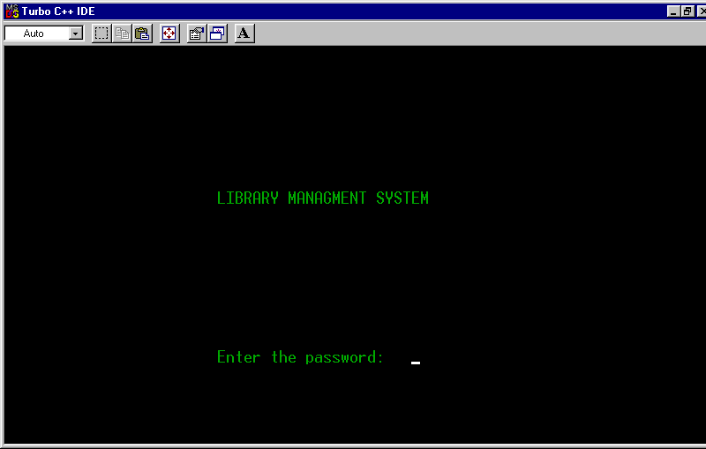

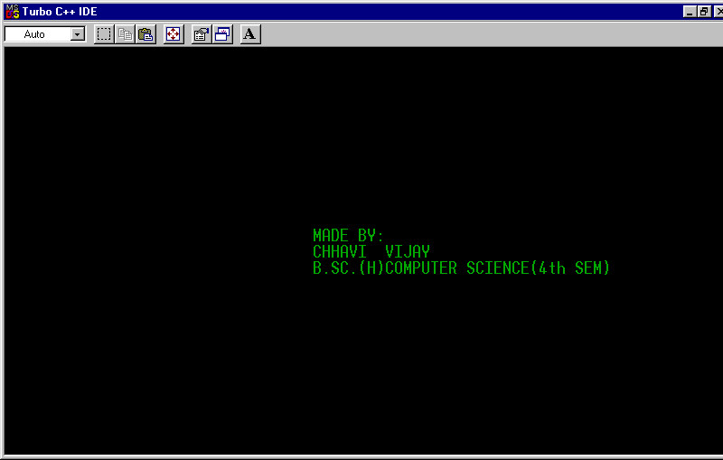

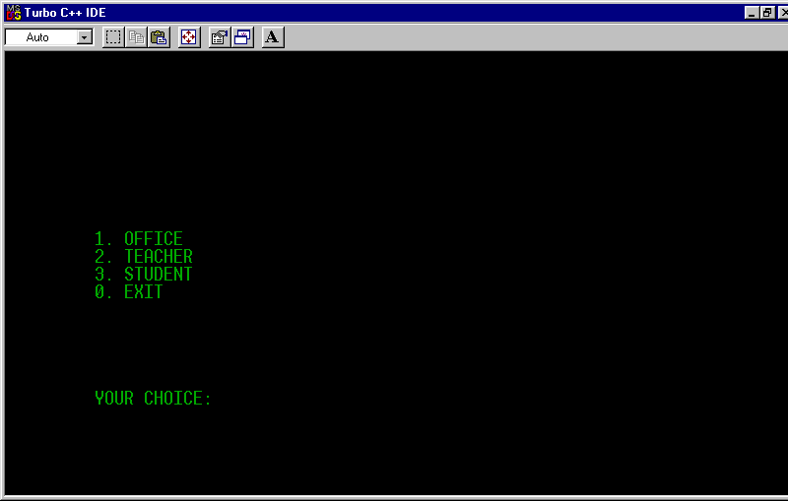

Main menu of the program.

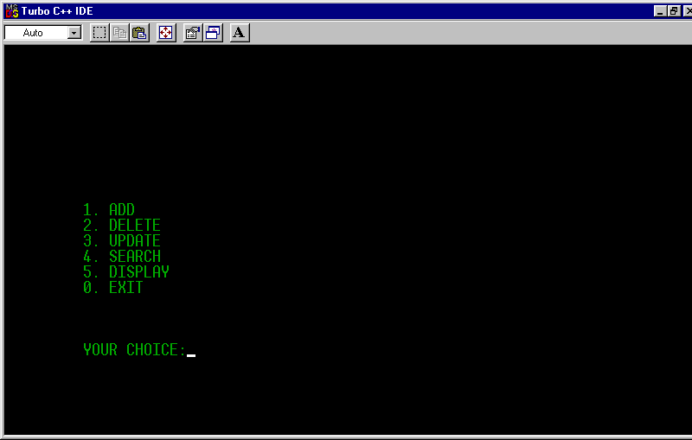

From main menu choice 1 is selected.

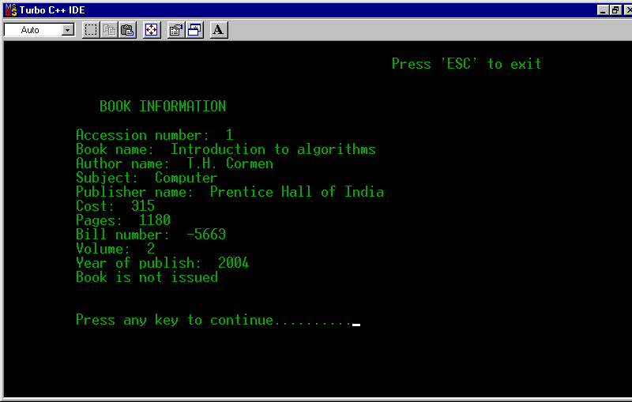

choice 5 is selected.

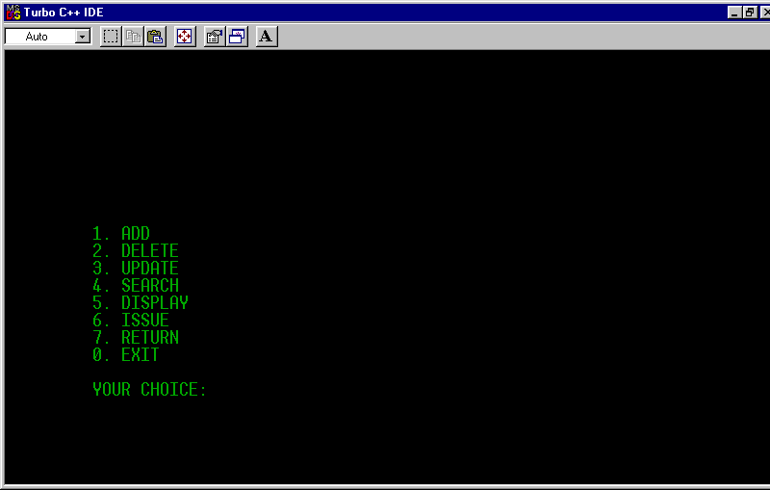

In main menu choice 3 is selected.

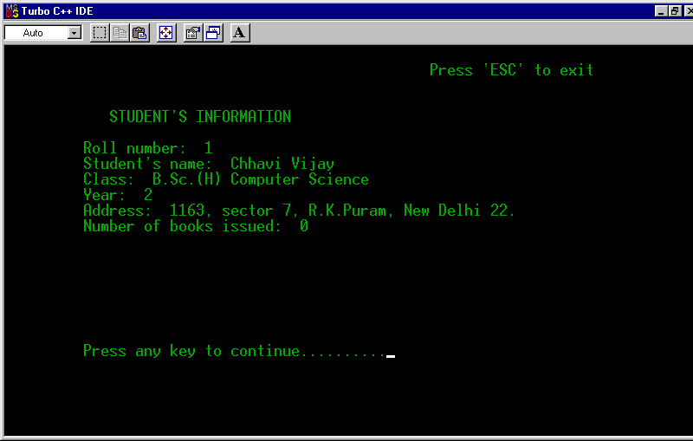

choice 5 is selected.

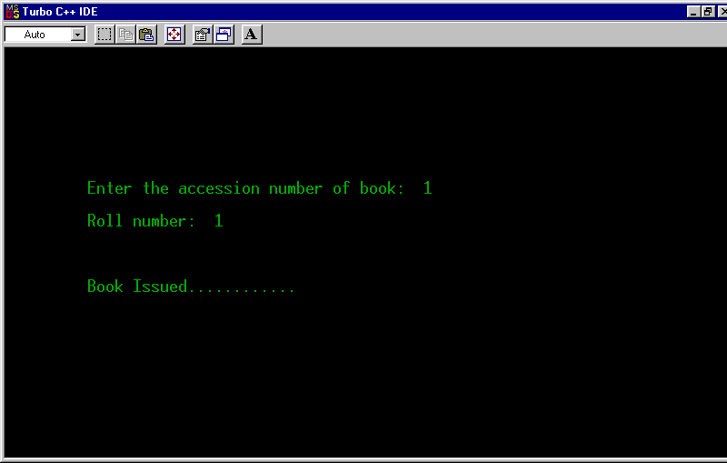

Choice 6 is selected to issue a book to the student.

--Testing

It is integral part of any system’s development life cycle without which the system developed is sure to fail and result in loss of economic and manpower investments besides user’s dissatisfaction and downfall of reputation.

System testing is the stage of implementation, which aims at ensuring that the system works accurately and efficiently before actual operation commences. No program or system design is perfect, communication between the user and the designer is not always complete or clear. All this can result in errors.

Another reason for system testing is its utility as a user oriented vehicle before implementation. The application system is worthless if does not meet user needs, thus the system should be tested to see whether it meets the user requirements.

Testing here is conducted in bottom up approach as follows:
- Module testing: Here testing is done at each module level. Each case has been throughly tested to discover pitfalls.
- System testing: Here testing is done after all the modules have been integrated.

